**■ PREPARTICIPATION PHYSICAL EVALUATION**

**PHYSICAL EXAMINATION FORM**

Name: _____________________________________________________________________________ Date of birth: ____________________________ …………………….(First Name) (Last Name)

**PHYSICIAN REMINDERS**

1. Consider additional questions on more-sensitive issues.

* Do you feel stressed out or under a lot of pressure?
* Do you ever feel sad, hopeless, depressed, or anxious?
* Do you feel safe at your home or residence?
* Have you ever tried cigarettes, e-cigarettes, chewing tobacco, snuff, or dip?
* During the past 30 days, did you use chewing tobacco, snuff, or dip?
* Do you drink alcohol or use any other drugs?
* Have you ever taken anabolic steroids or used any other performance-enhancing supplement?
* Have you ever taken any supplements to help you gain or lose weight or improve your performance?
* Do you wear a seat belt, use a helmet, and use condoms?

2. Consider reviewing questions on cardiovascular symptoms (Q4–Q13 of History Form).

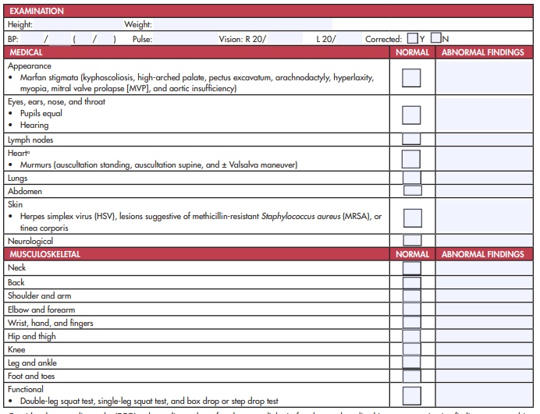

Consider electrocardiography (ECG), echocardiography, referral to a cardiologist for abnormal cardiac history or examination findings, or a combination of those.

Name of health care professional (print or type): ___________________________________________________________ Date: ___________________

Address: __________________________________________________________________________________ Phone: ___________________________

Signature of health care professional: _____________________________________________________________________________ MD, DO, NP, or PA

_______________________________________________________________________________________________________________

© 2019 American Academy of Family Physicians, American Academy of Pediatrics, American College of Sports Medicine, American Medical Society for Sports Medicine, American Orthopaedic Society for Sports Medicine, and American Osteopathic Academy of Sports Medicine. Permission is granted to reprint for noncommercial, educational purposes with acknowledgment.

**PAGE 2**